School Name
Mathematics Test 2017
Year 8 |  | Polygons and Circles | Calculator Allowed Test
Skills and Knowledge Assessed:  - Classify triangles according to their side and angle properties and describe quadrilaterals (ACMMG165)  - Demonstrate that the angle sum of a triangle is 180° and use this to find the angle sum of a quadrilateral (ACMMG166)  - Identify line and rotational symmetries (ACMMG181)  - Investigate the relationship between features of circles such as circumference, area, radius and diameter. (ACMMG197) |  |  | Name___________________
Answer all questions in the spaces provided on this test paper by:
Writing the answer in the box or on the lines provided.
or
Shading in the bubble for the correct answer from the four choices provided.
Show any working out on the test paper. Calculators are allowed.
Geometric Instruments are required for this test.
What type of quadrilateral is shown here?

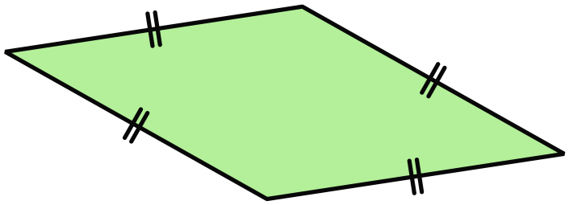 A kite
A parallelogram
A rhombus.
A trapezium

- 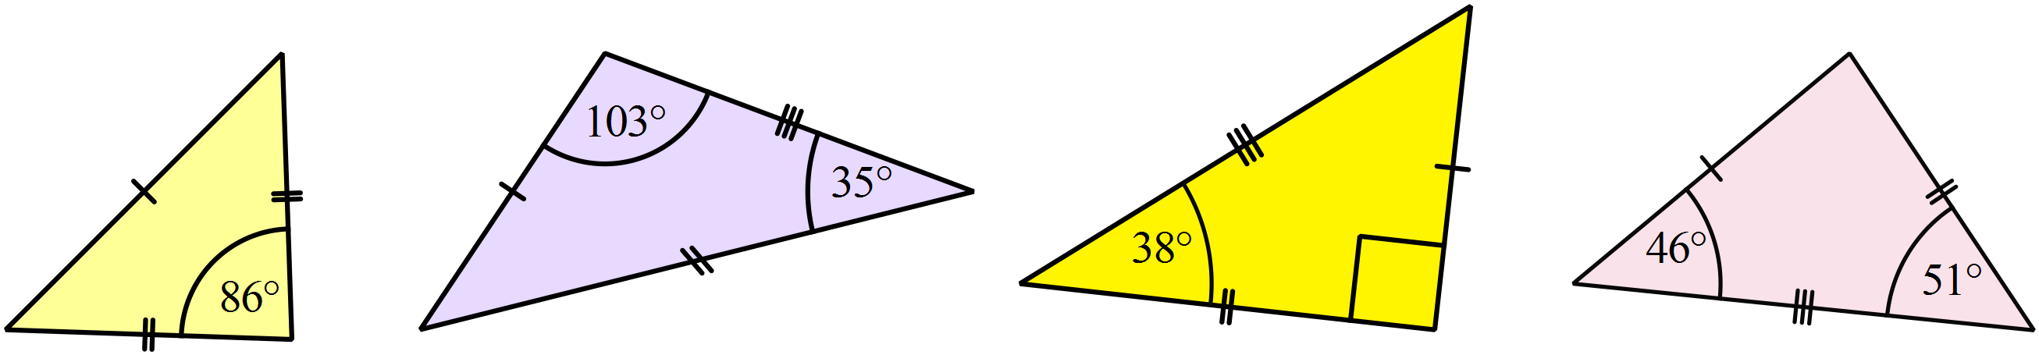 | Which figure shows an acute scalene triangle? (Diagrams are not to scale.)
Which figure shows an irregular pentagon?
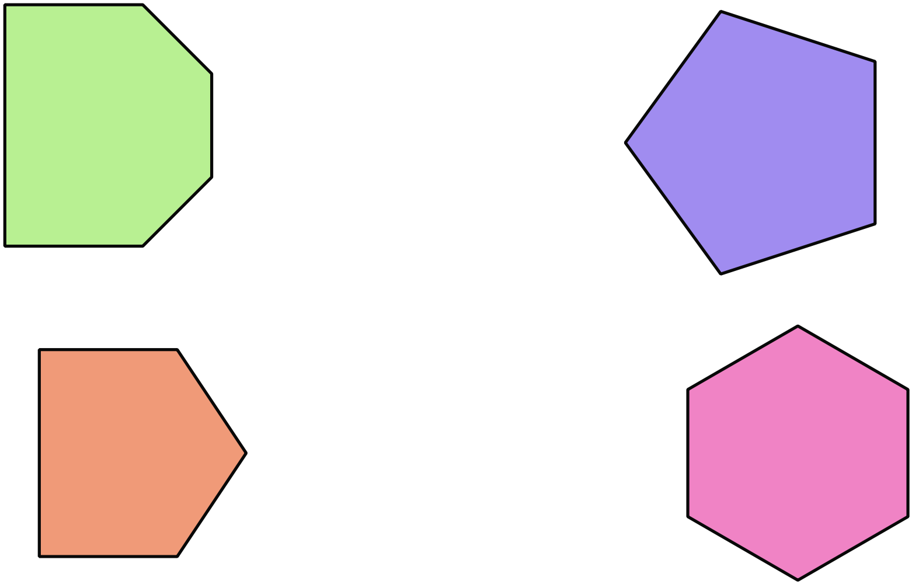

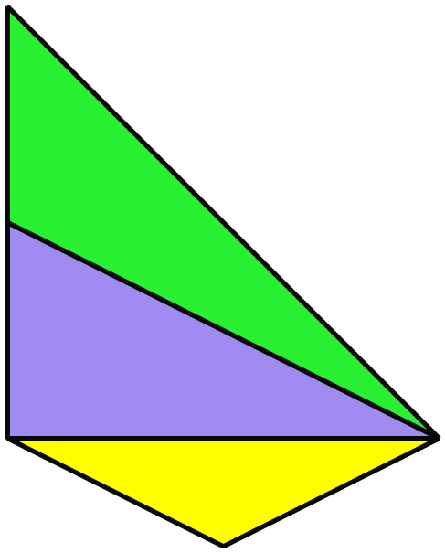In the design below, which type of triangle is not included?

Acute isosceles triangle
Obtuse isosceles triangle
Obtuse scalene triangle
Right scalene triangle

Which is a true statement about the kite shown?
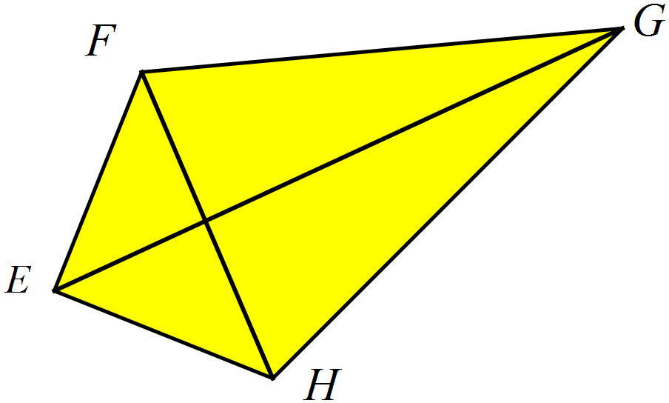
The diagonals EG and FH are equal in length.
The diagonal EG is equal to the side FG.
The side FG is equal to the side FE.
The side EF is equal to the side EH.

C is the centre of the circle shown.
Write down the names of the two features of the circle, indicated by the arrows.
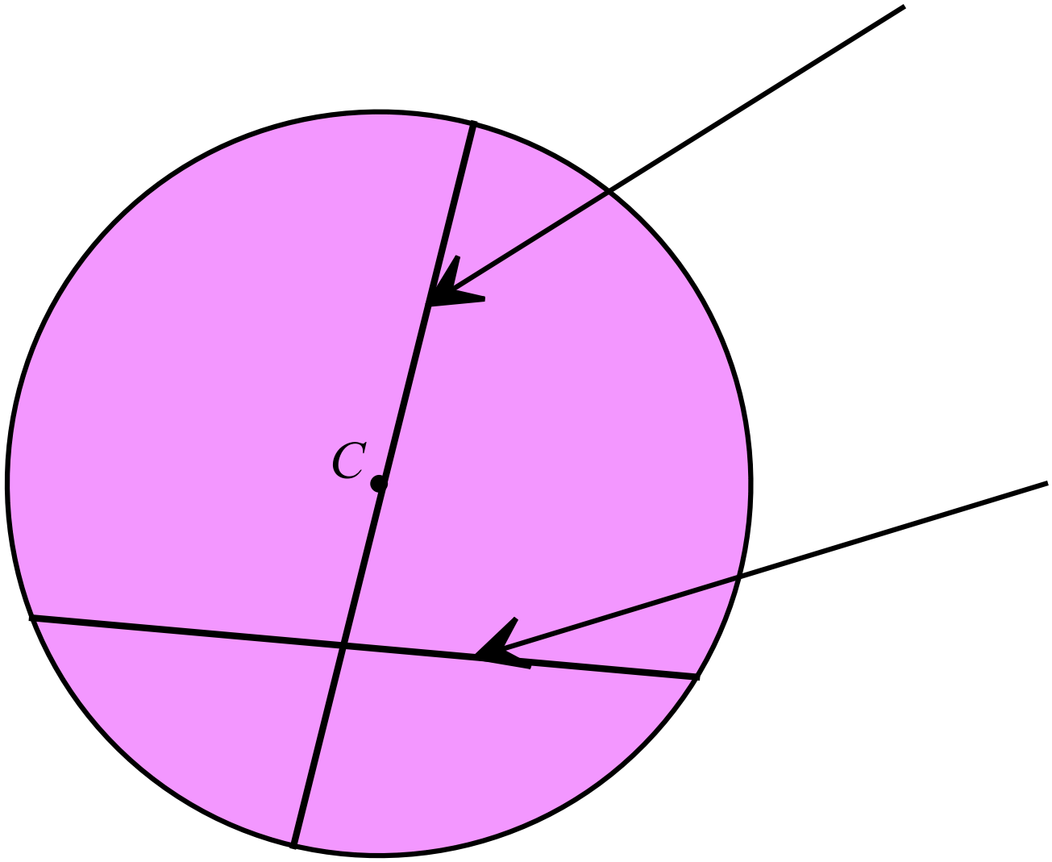

What is the size of 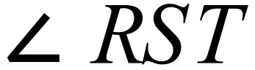 in the triangle below?
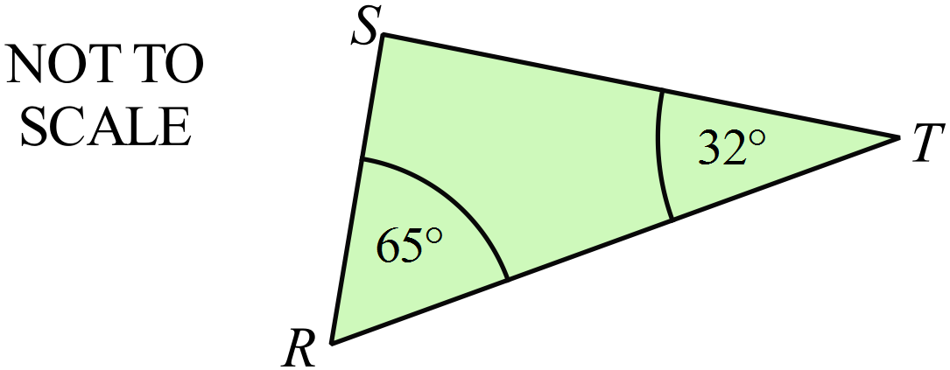

Is the triangle below, right angled ? ( Explain why.)
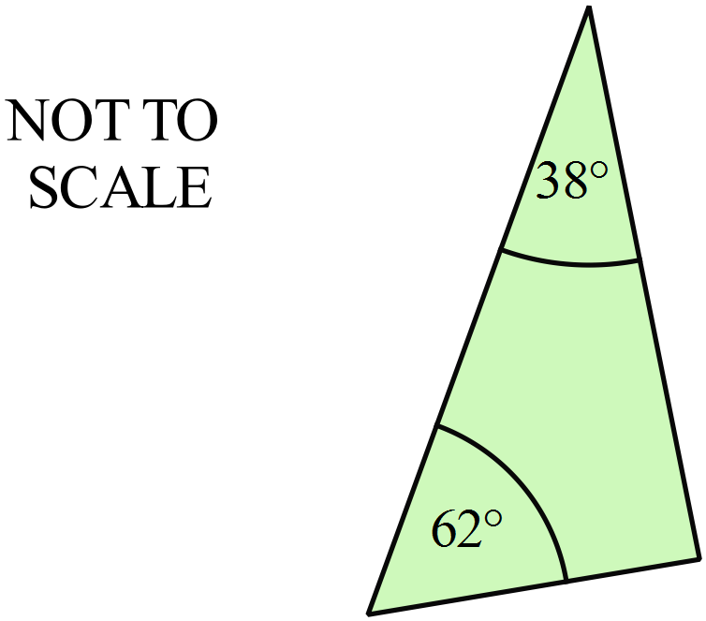

___________________________________

___________________________________

___________________________________
 | 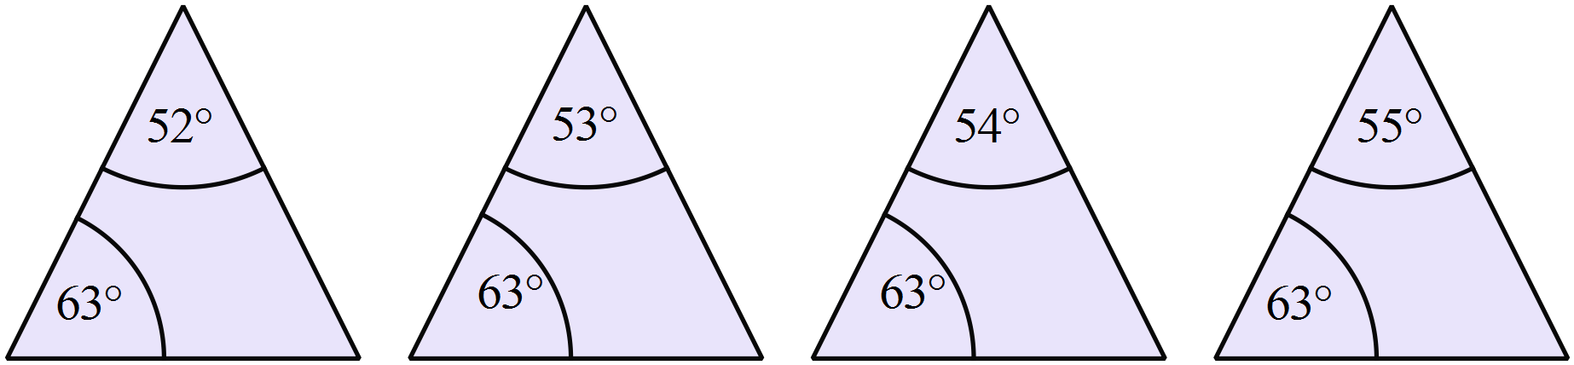Which figure shows an isosceles triangle? ( Diagrams are not to scale)
What is the value of 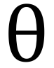 in the quadrilateral below?
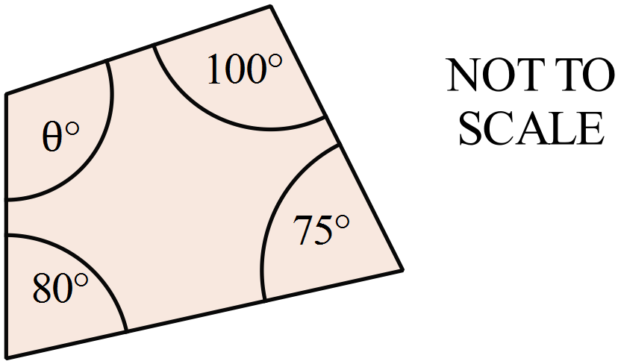

A polygon has the properties listed below.
- Angle sum is 360º.
- All sides are equal.
- Does not include a right angle.
What name could be given to the polygon?
An equilateral triangle
An isosceles triangle
A rhombus
A square
Find the size of 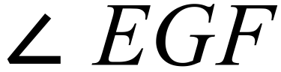 in the diagram below.
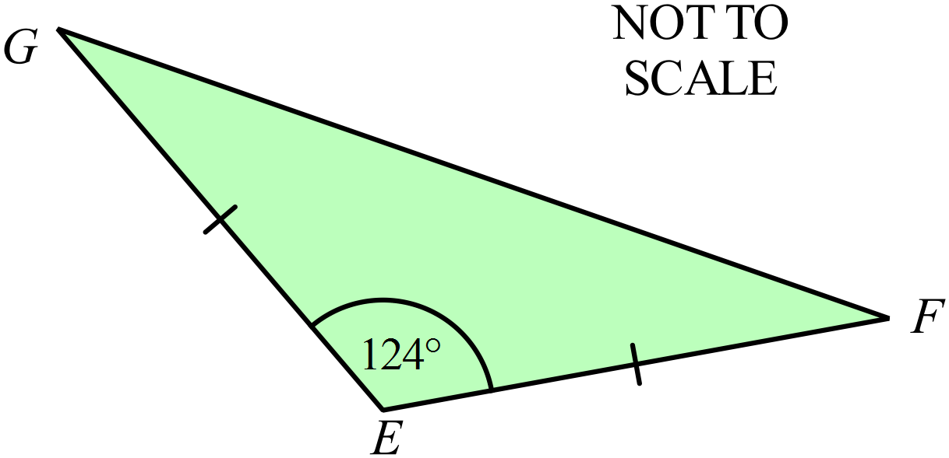

O is the centre of the circle below.
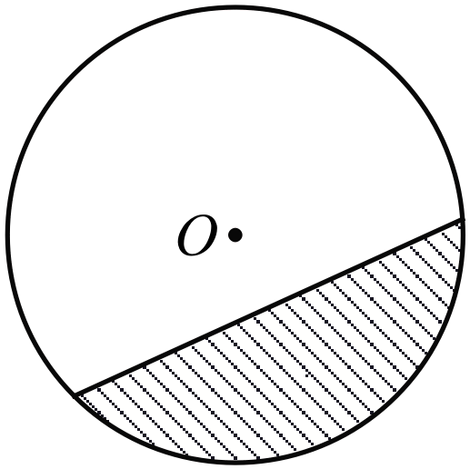What name is given to the shaded region?

A minor sector
A minor segment
A quadrant
A semicircle

Which of the following quadrilaterals could be either a convex or non-convex polygon?
A kite
A parallelogram
A rectangle
A rhombus
 | 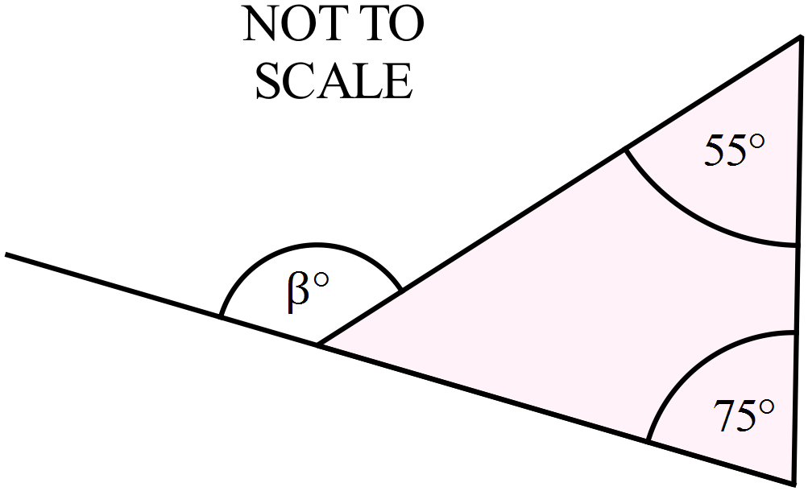What is the value of 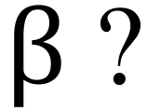
Which of the following has rotational symmetry but no line symmetry?
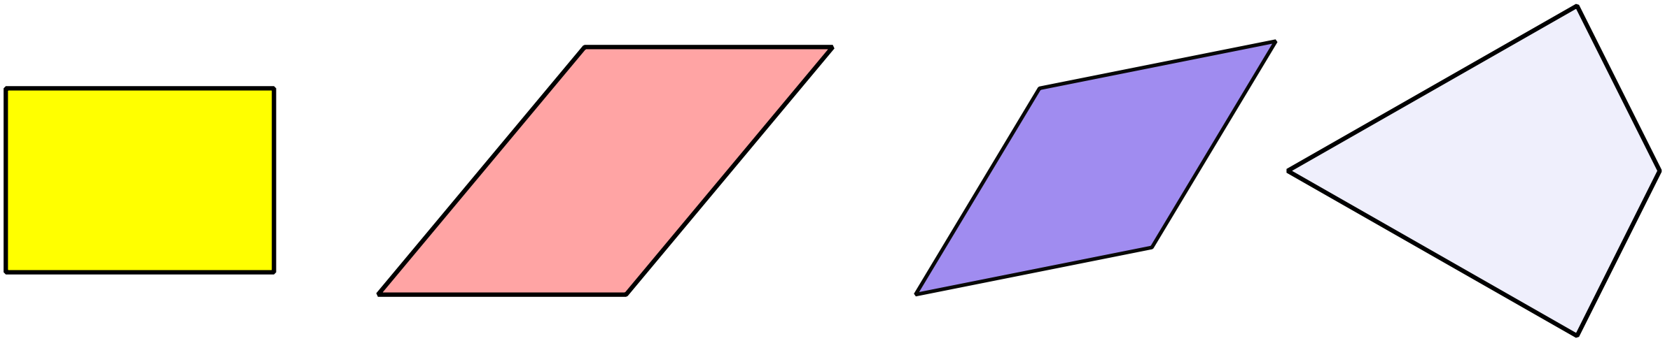

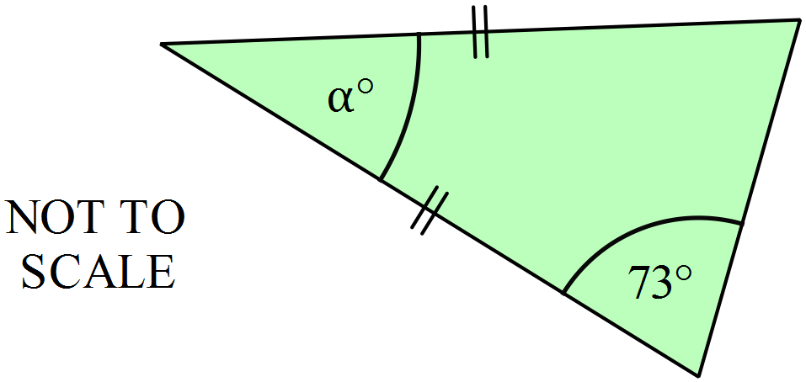Find the value of  in the diagram below.
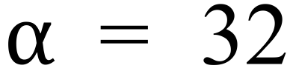
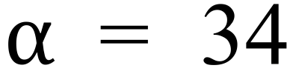
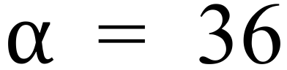
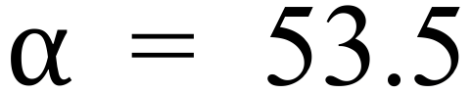

A regular octagon is shown below, with the opposite vertices joined by their diagonals.

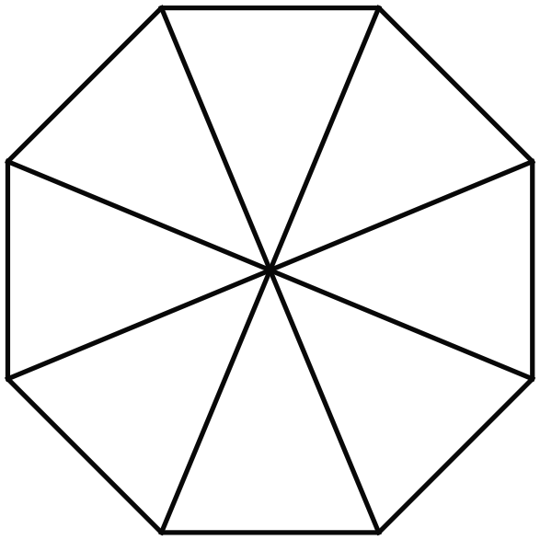Which of these shapes cannot be found within the diagram?

An isosceles triangle
A kite
An irregular pentagon
A rhombus

Which of the following quadrilaterals has diagonals which are equal and which bisect one another?
A kite
A parallelogram
A rectangle
A rhombus
 | 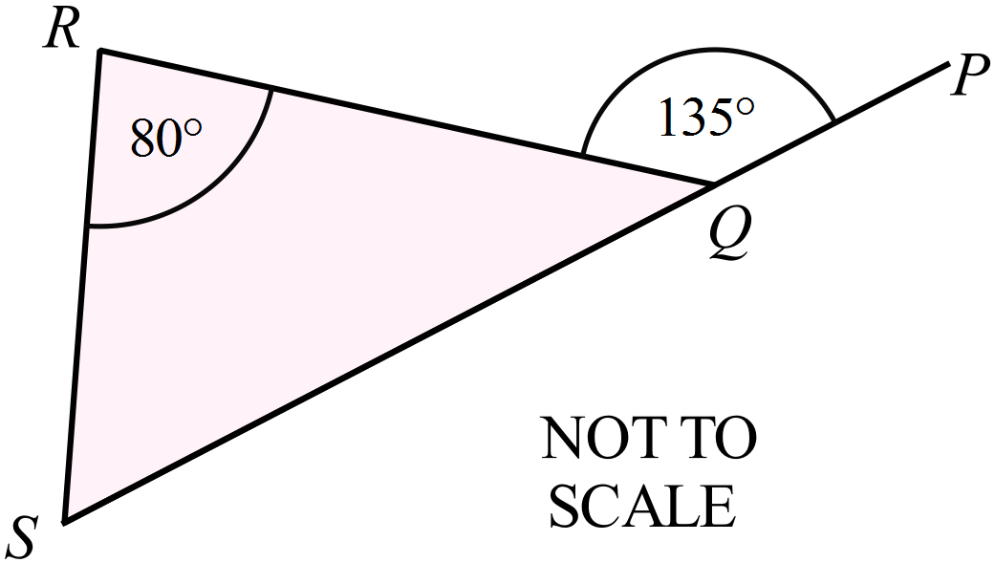What is the size of 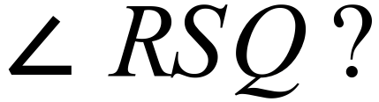
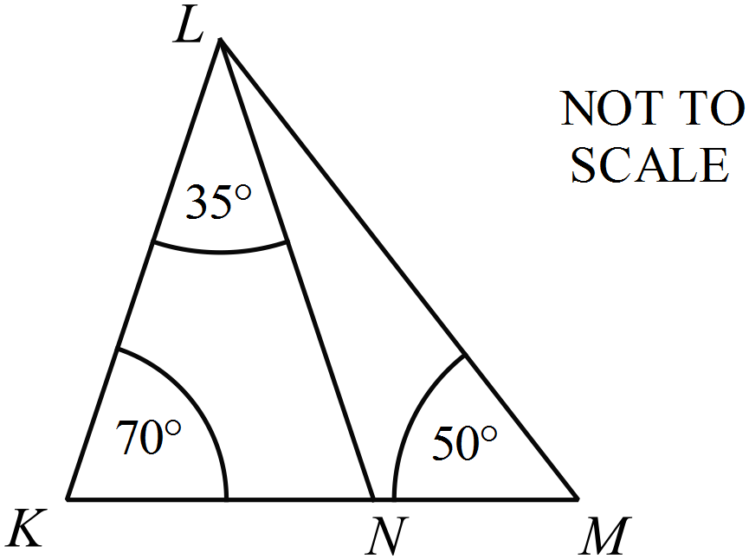Find the size of 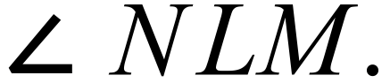 .

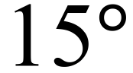
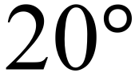
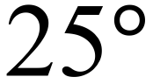
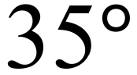

Which statement describes the symmetry of this shape?

No line symmetry and rotational symmetry of order 3.
3 axes of symmetry and no rotational symmetry
3 axes of symmetry and rotational symmetry of order 3
6 axes of symmetry and rotational symmetry of order 6

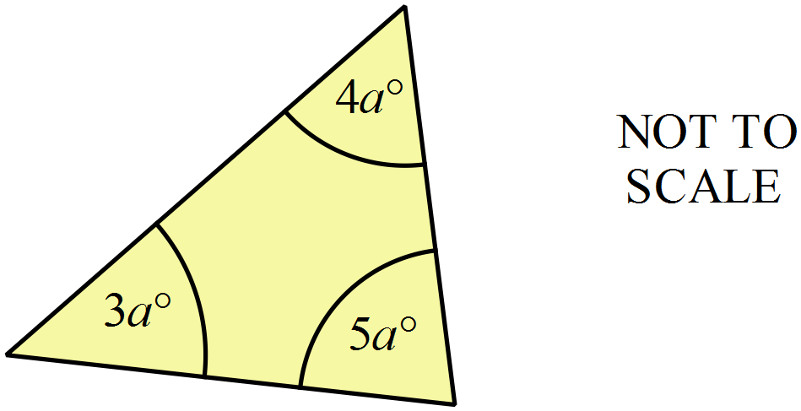What is the value of 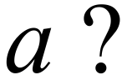

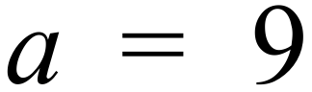
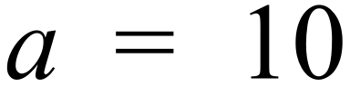
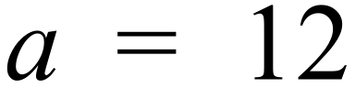
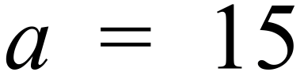

 | 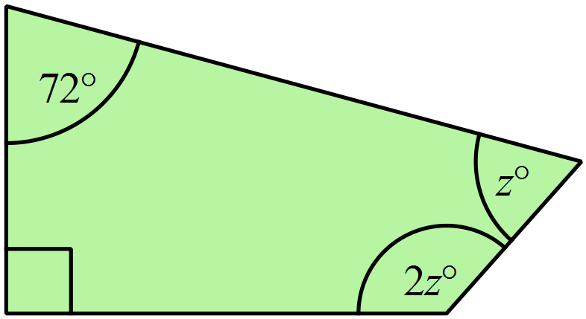What is the value of z?
The figure ABCD is a rectangle and AEFG is a parallelogram.
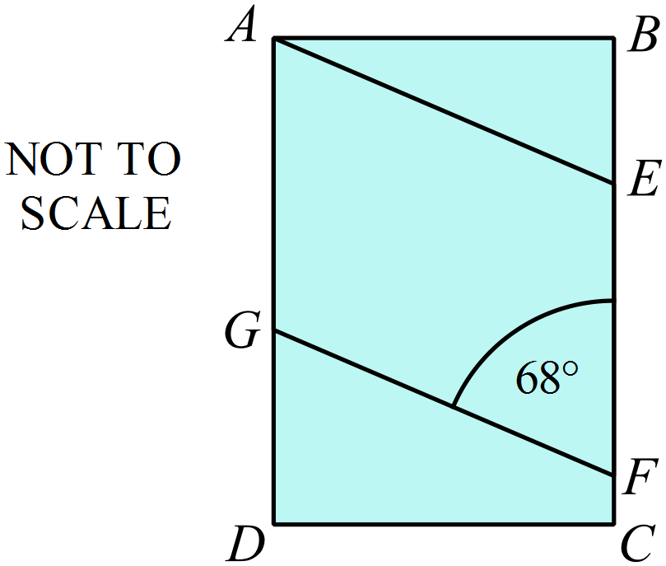What is the size of 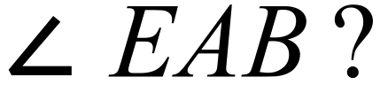

When you think of a kite, a rhombus and a parallelogram, which of these properties is only true of the rhombus and not of the other two quadrilaterals?
Both diagonals are axes of line symmetry.
Each diagonal bisects the other.
The diagonals are equal.
The diagonals meet at right angles.
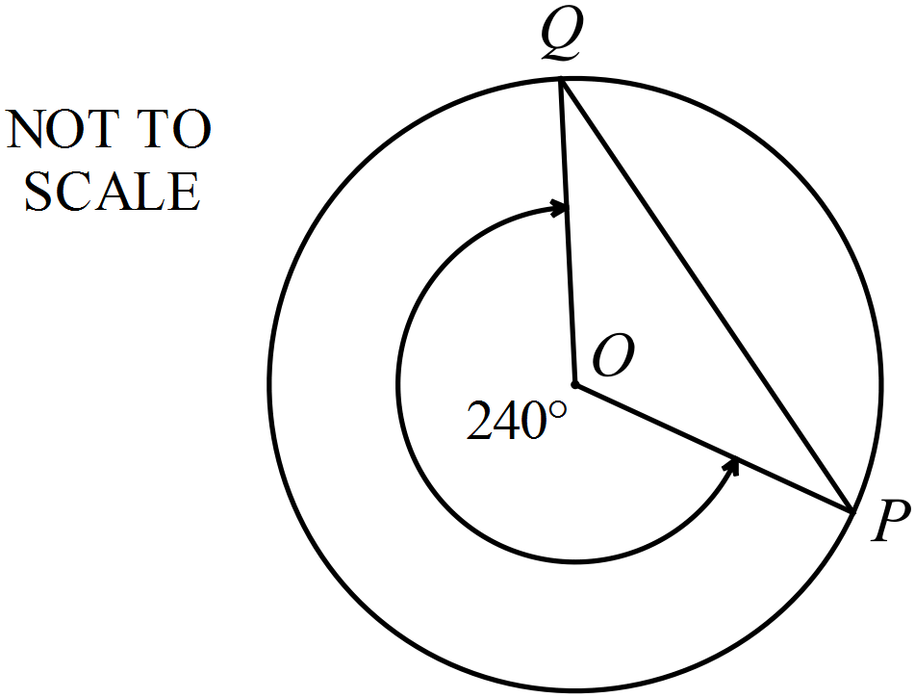O is the centre of the circle and P and Q are points on its circumference.
What is the size of 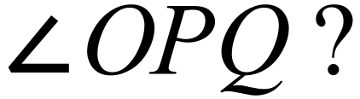

 | 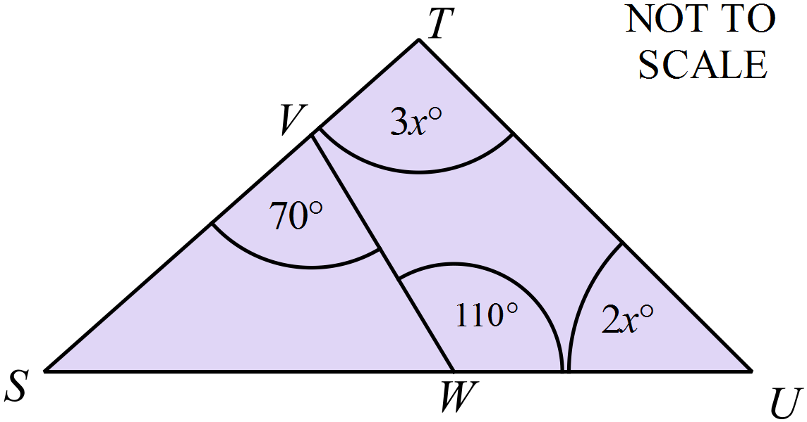Find the value of x.
 | 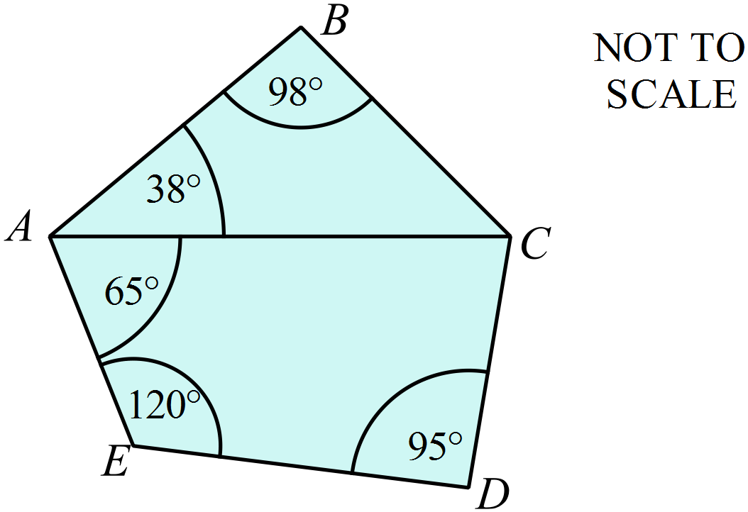What is the size of 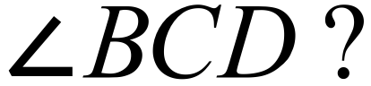
O is the centre of the circle and A, B and C are points on its circumference.
Find an expression in terms of c for the size of 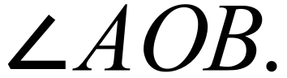
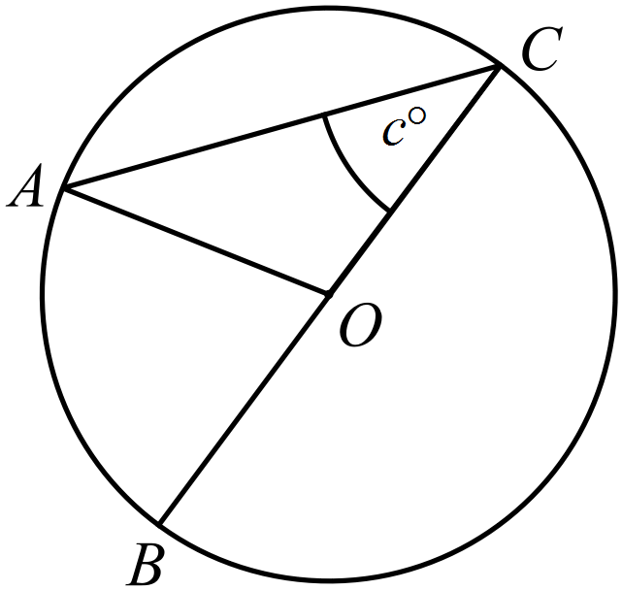

School Name
Mathematics Test 2017
Year 8 | Polygons and Circles | Longer Answer  Section
 |  | Name___________________
Write all working and answers in the spaces provided on this test paper.
Marks may not be awarded if working out and/or answers are not clear.
Marks allocated are shown beside each question.
Calculators are allowed.

 |  | Marks
 | - Use instruments to accurately draw a parallelogram PQRS and place markings on the diagram to show any equal sides and angles. | 2
 | - Measure the angles in the parallelogram and use this to describe one of the angle properties of the parallelogram.  ……………………………………………………………………………………..  …………………………………………………………………………………….. | 2
 | - EFG is an equilateral triangle and FGH is an isosceles triangle.  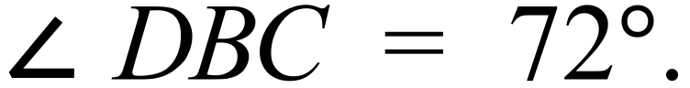  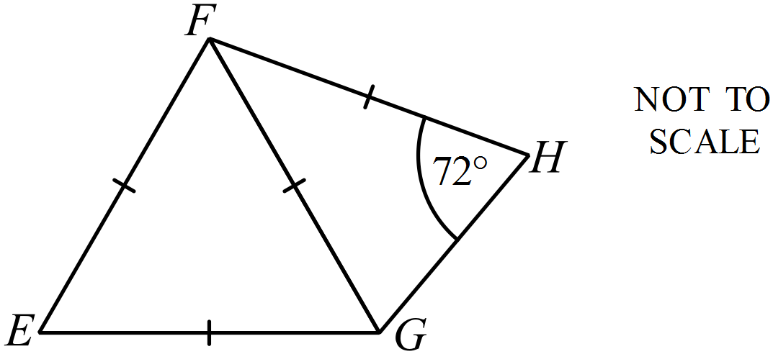  Find the size of 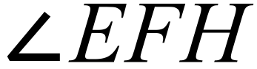, giving reasons for your answer.  ……………………………………………………………………………………..  ……………………………………………………………………………………..  …………………………………………………………………………………….. | 3
 | (b) STUV is a kite. SU and TV are the diagonals which intersect at W.  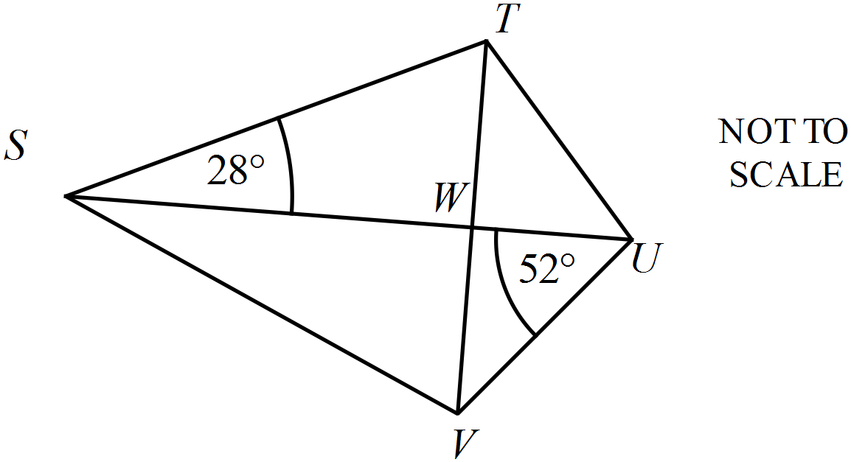Find the size of 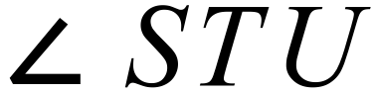 , giving reasons for your answer.  ……………………………………………………………………………………..  ……………………………………………………………………………………..  …………………………………………………………………………………….. | 3

School Name
Mathematics Test 2017
Year 8 | Polygons and Circles | Calculator Test
ANSWERS

Question | Working and Answer
Having all sides equal, it is a rhombus.

3rd Answer
Only figure 4 is both scalene and acute angled, (the missing angle is 83º.)

4th Answer
The 2nd and 3rd figures are pentagons, only the 3rd is irregular.

3rd Answer
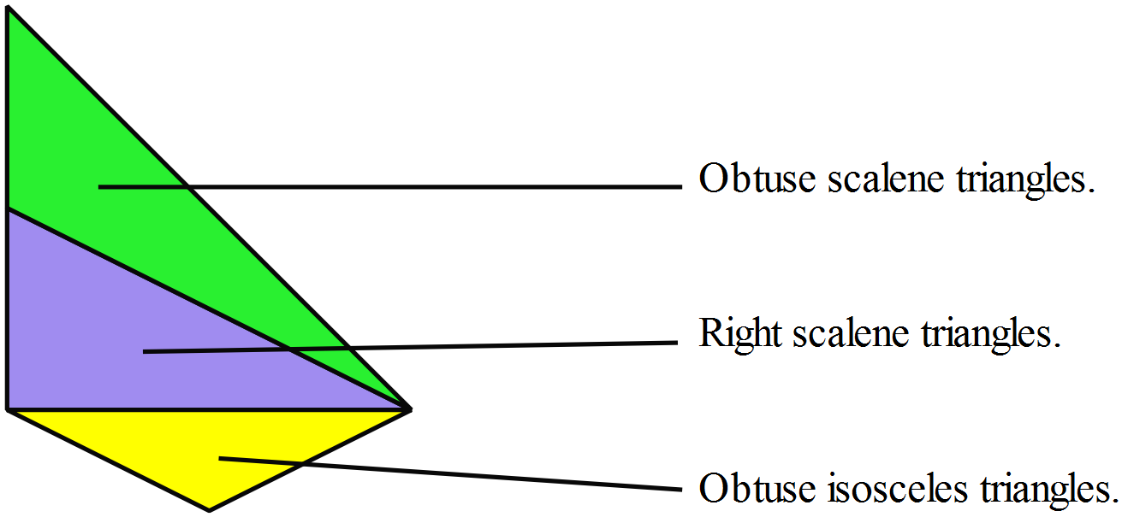

There is no acute isosceles triangle
1st Answer
The sides adjacent to one another and on opposite sides of the axis of symmetry are equal, so side EF is equal to the side EH.
4th Answer.
A chord joins two points on the circumference.
A diameter joins two points on the circumference and passes through the centre.
Diameter

Chord

 | 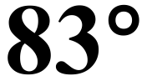
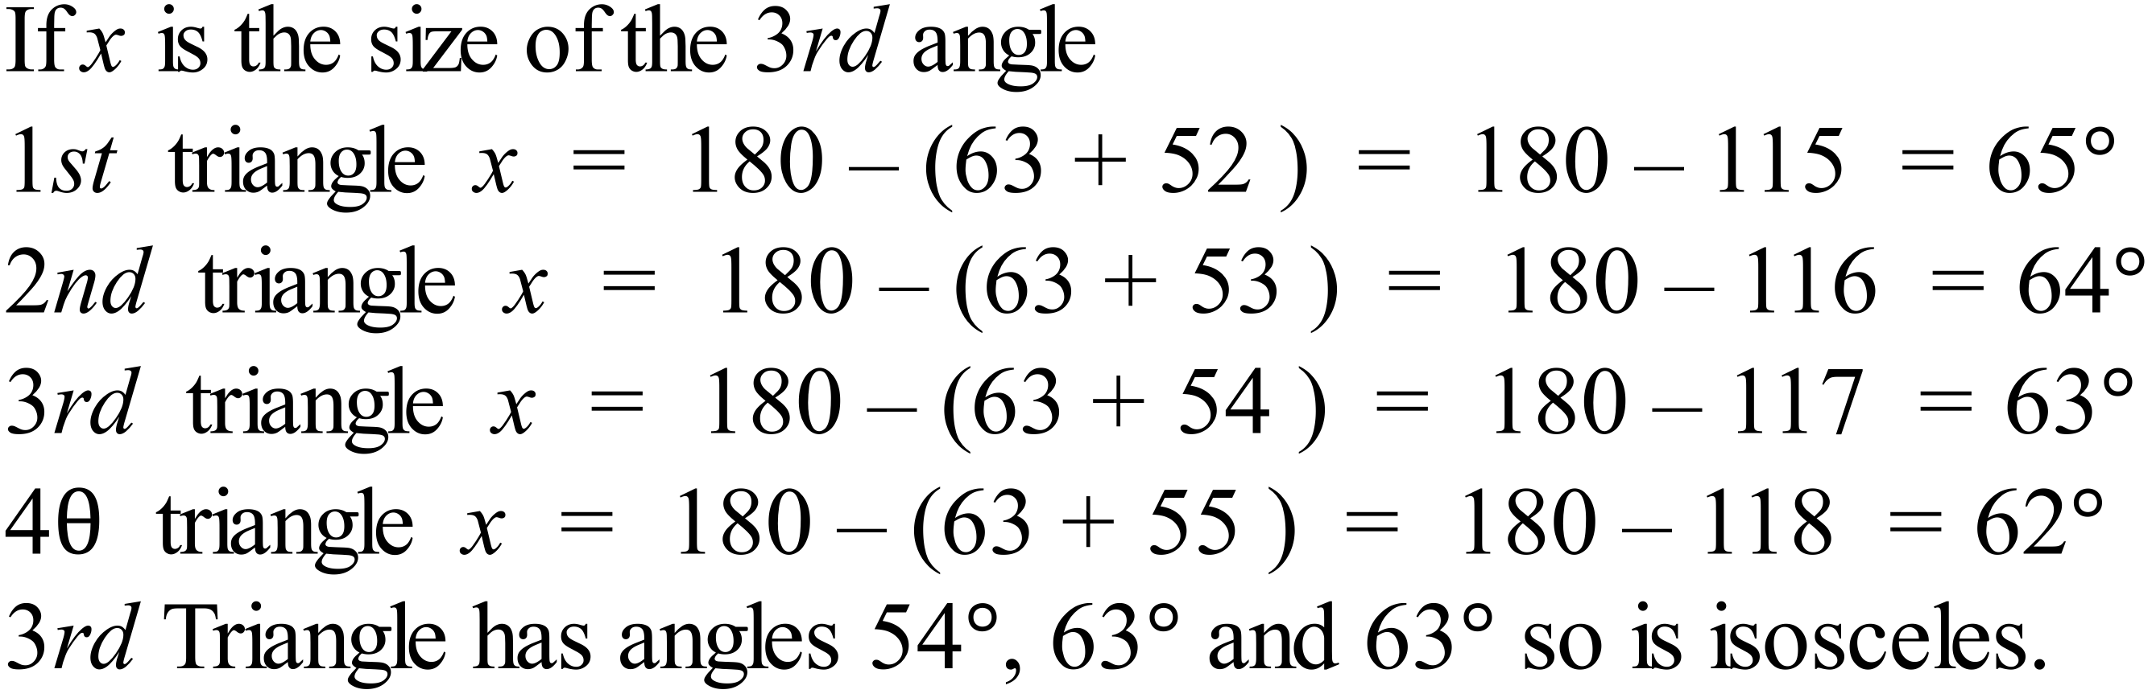
3rd Answer
 | 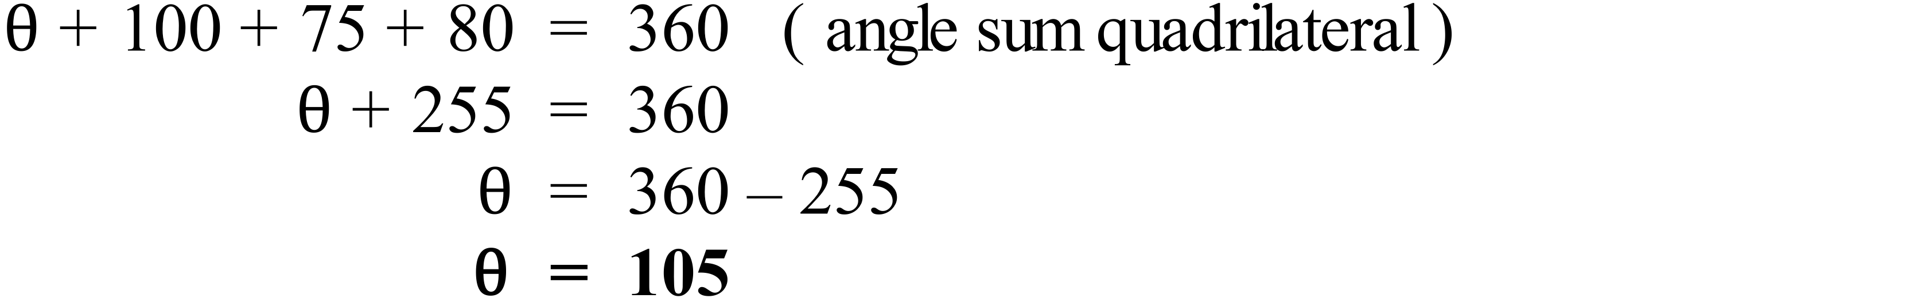
- Angle sum is 360º. . It is a quadrilateral
- All sides are equal. it is a rhombus (or square)
- Does not include a right angle. . it isn’t a square so rhombus
3rd Answer
 | 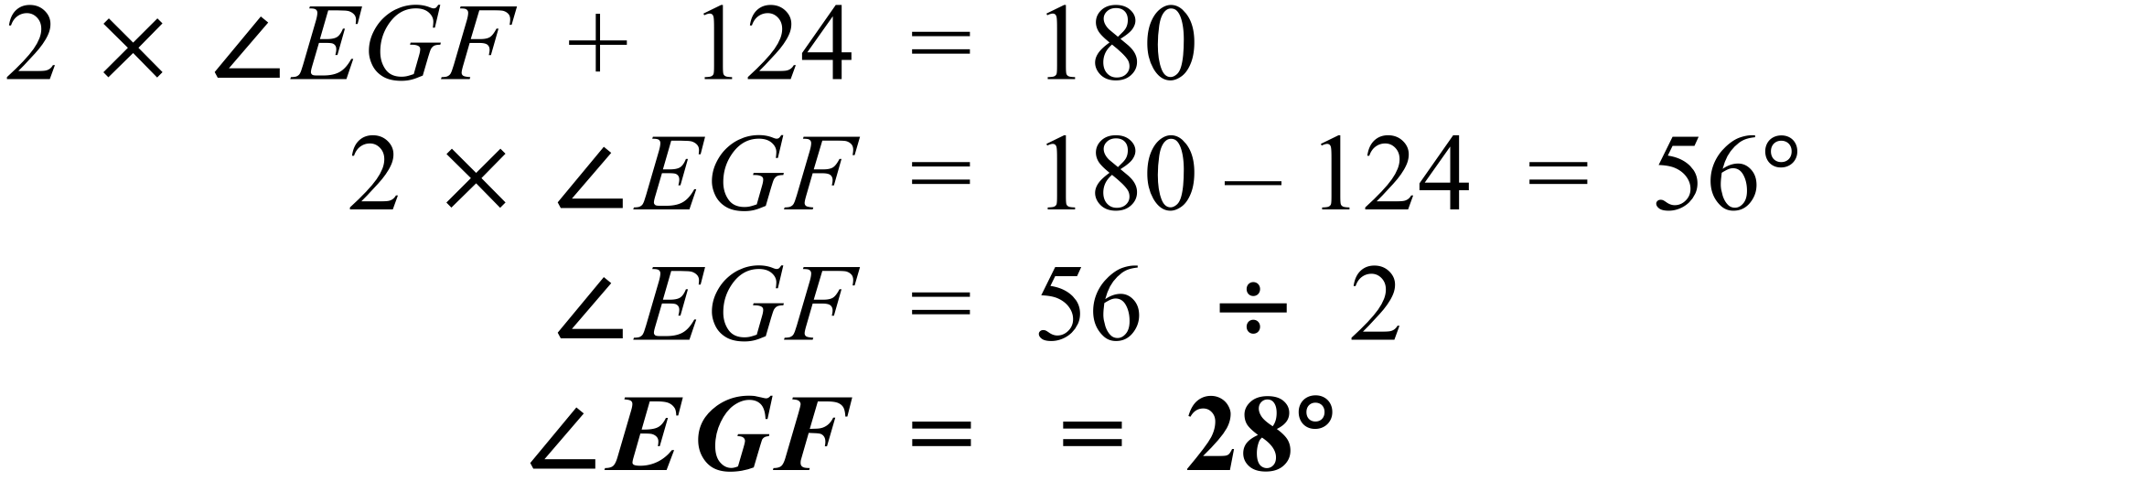
The region is cut off by a chord and makes up less than half of the circle, so it is a minor segment.
2nd Answer
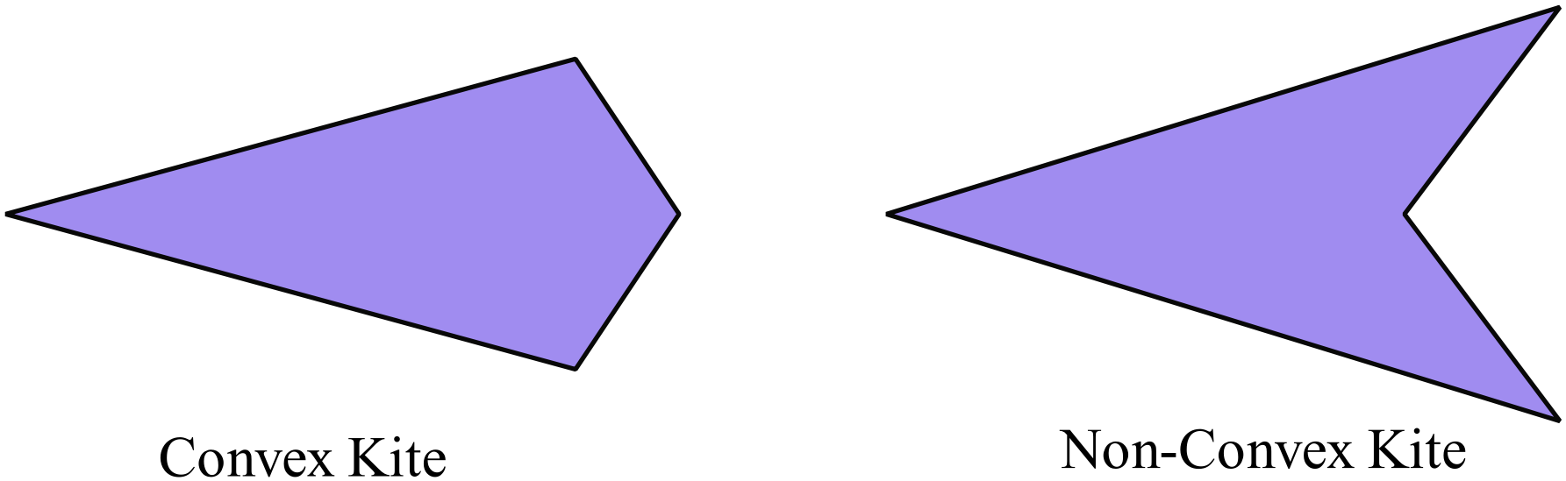

1st Answer
 | 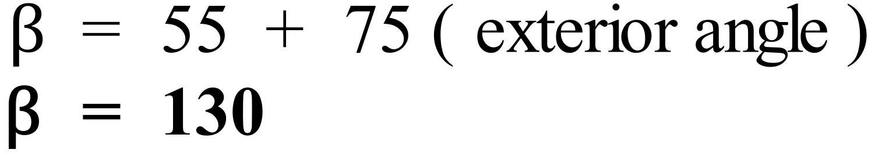
The parallelogram (figure 2) has no line symmetry but has rotational symmetry of order 2. All of the others have line symmetry.
2nd Answer
 | 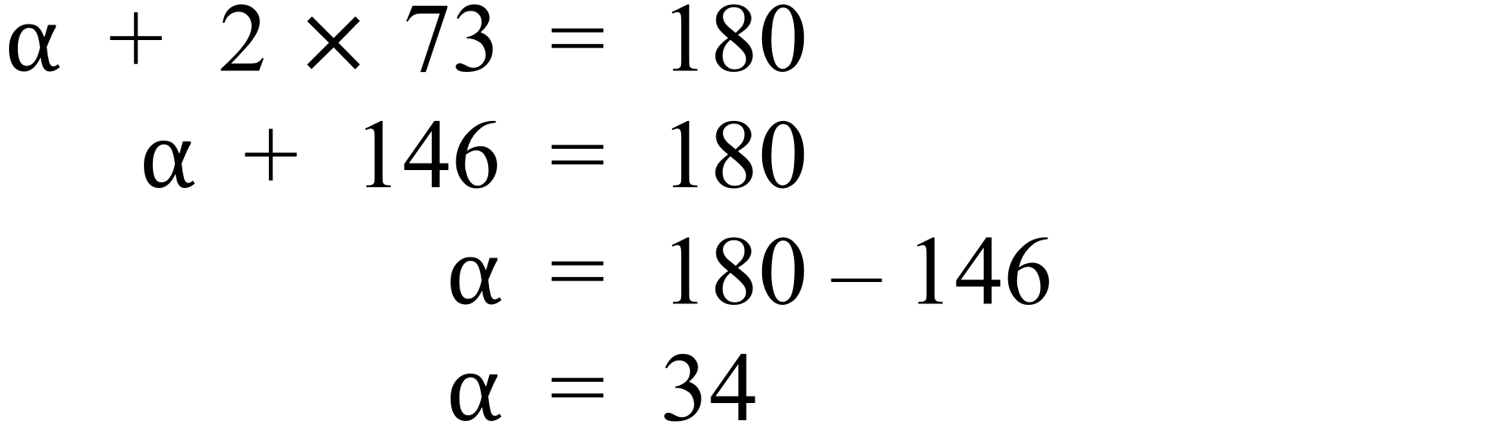
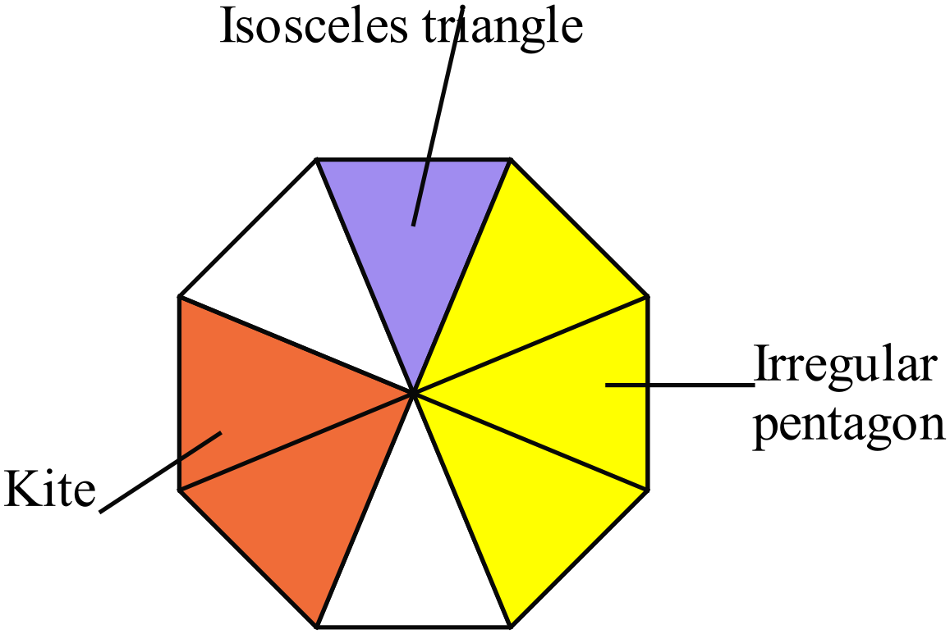

A rhombus cannot be found.
4th Answer
A kite Diagonals could be equal but only one bisects the other
Parallelogram Diagonals are not equal
A rectangle Diagonals are equal and bisect one another
A rhombus Diagonals are not equal
3rd Answer
 | 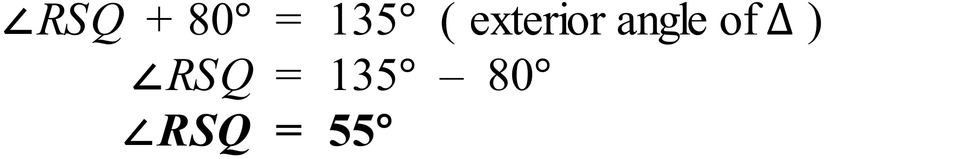
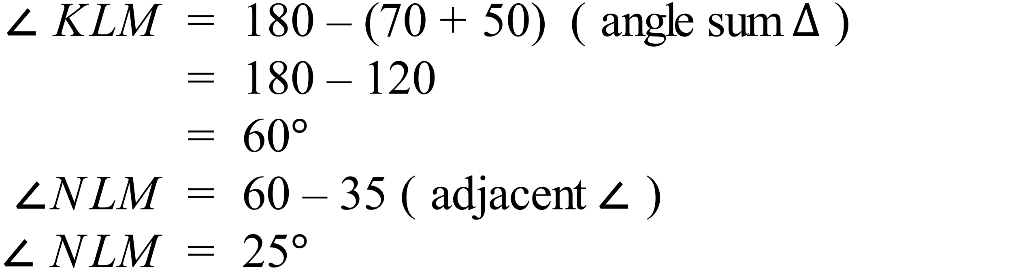
3rd Answer
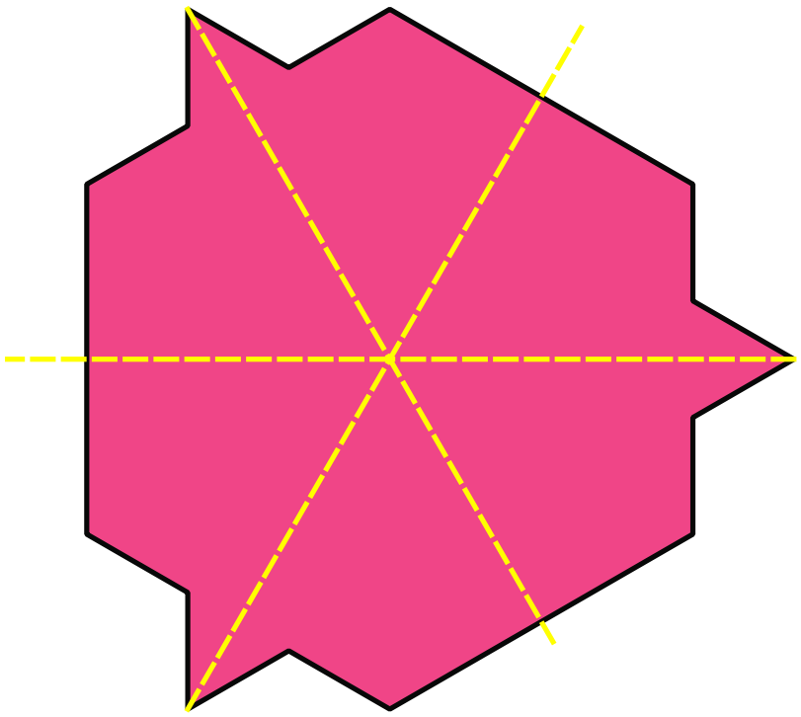There are 3 axes of symmetry as shown
There are 3 positions to which it can rotate, so order 3.

3rd Answer
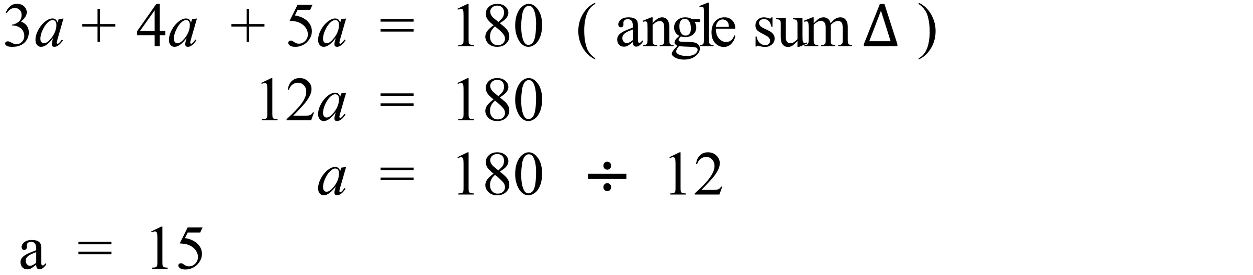
4th Answer
 | 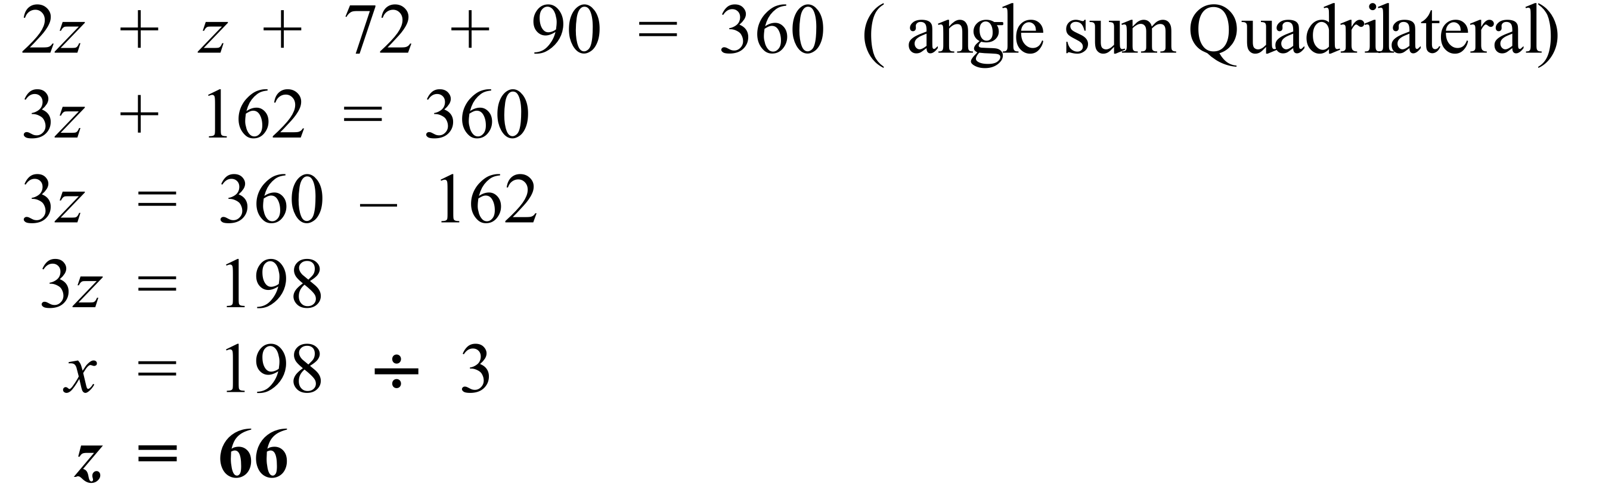
 | 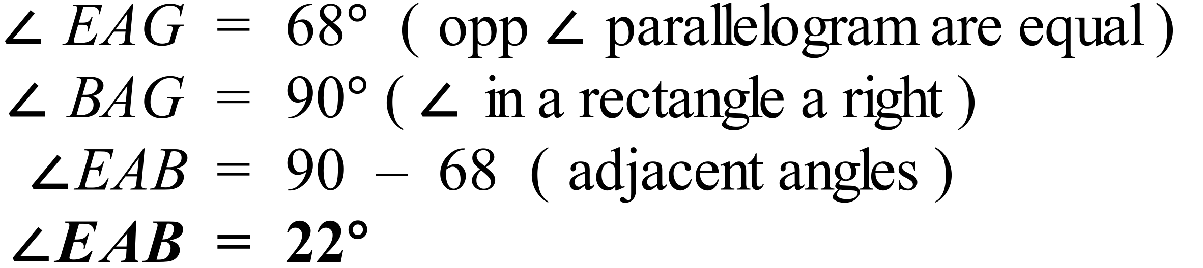
Both diagonals are axes of line symmetry. Only true of the rhombus, the parallelogram has no line symmetery and the kite has one diagoanl as an axis of symmetry
Each diagonal bisects the other. True of the rhombus and the parallelogram
The diagonals are equal. Not true of the rhombus
The diagonals meet at right angles. True of the rhombus and the kite
1st Answer

 | 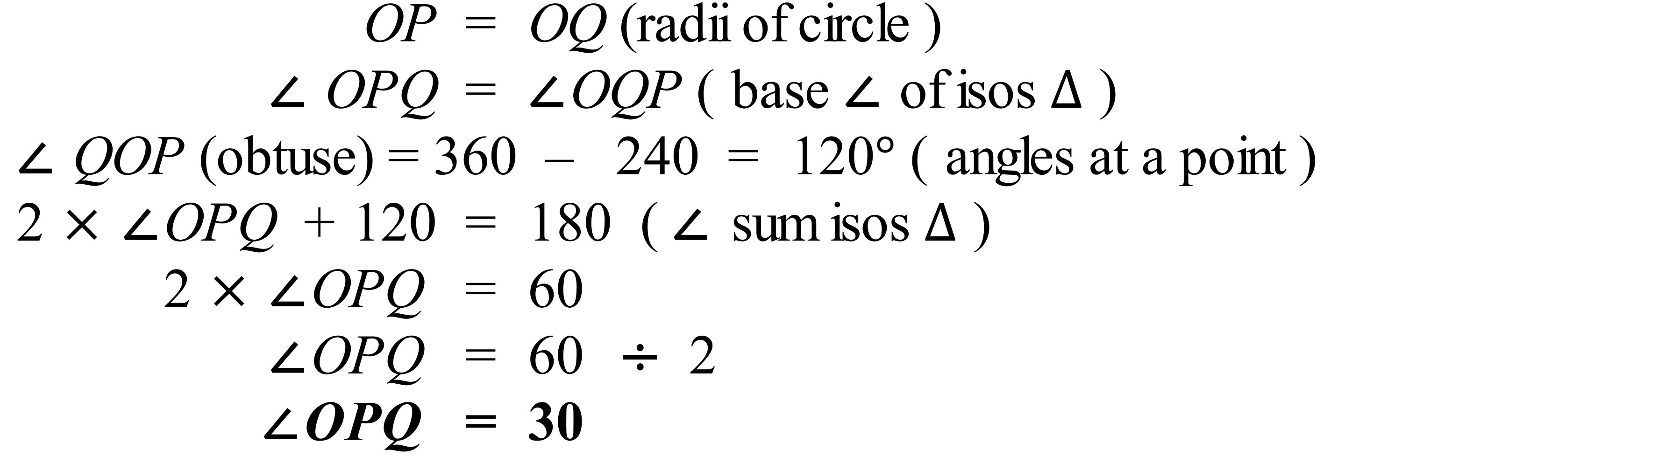
 | 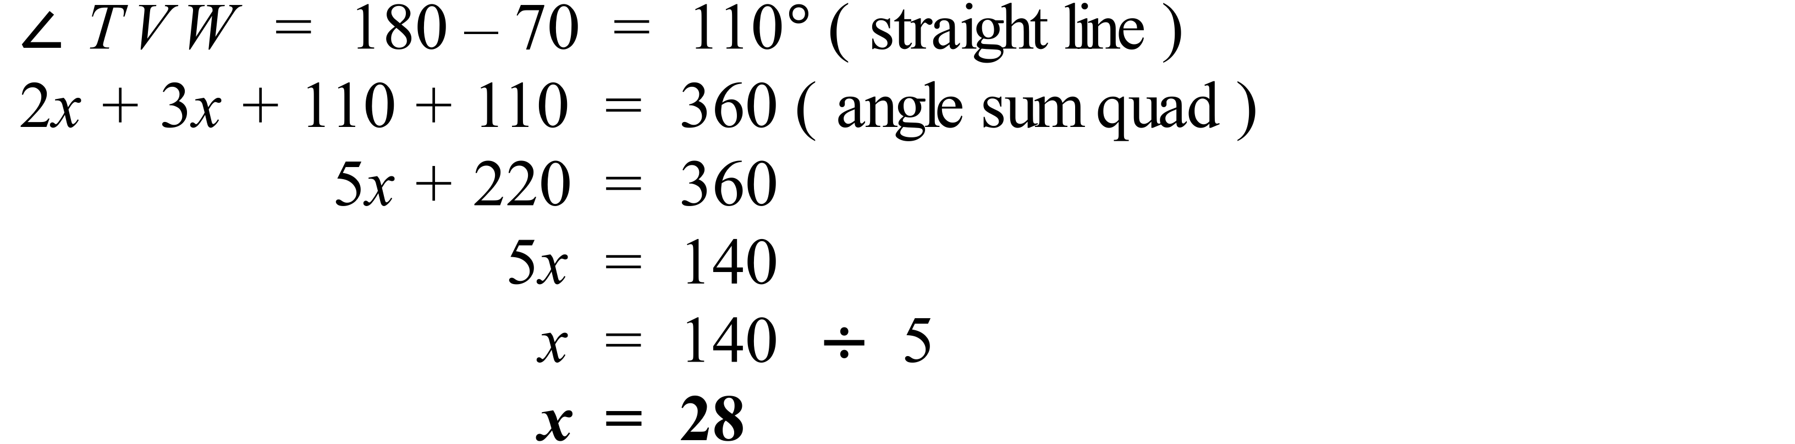
 | 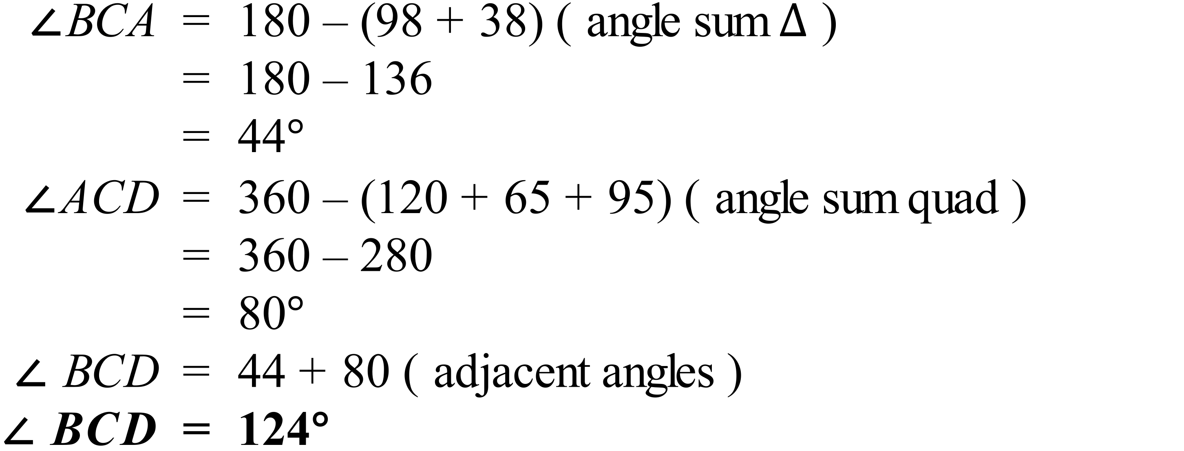
 | 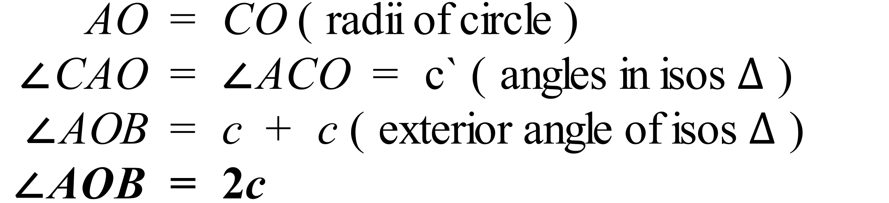

School Name
Mathematics Test 2017
Year 8 | Polygons and Circles | Longer Answer  Section
ANSWERS
Question | Answer | Marks
1. | (a)  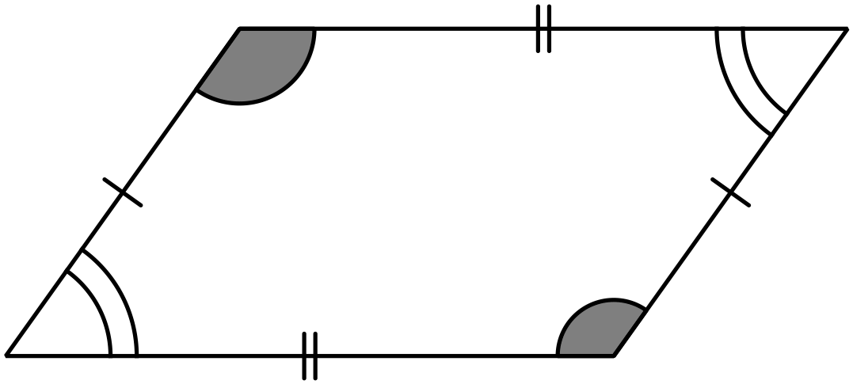 | 2 marks for accurately drawn and labelled diagram.  1 mark if accuracy or labelling are lacking
 | (b) The angles above are 126º and 54º for example.  The opposite angles of the parallelogram are equal. The cointerior angles of the parallelogram are supplementary.  The angle sum is 360º. | 1 mark for accurately measured angles  1 mark for any correct statement about the angle properties
2. | (a) 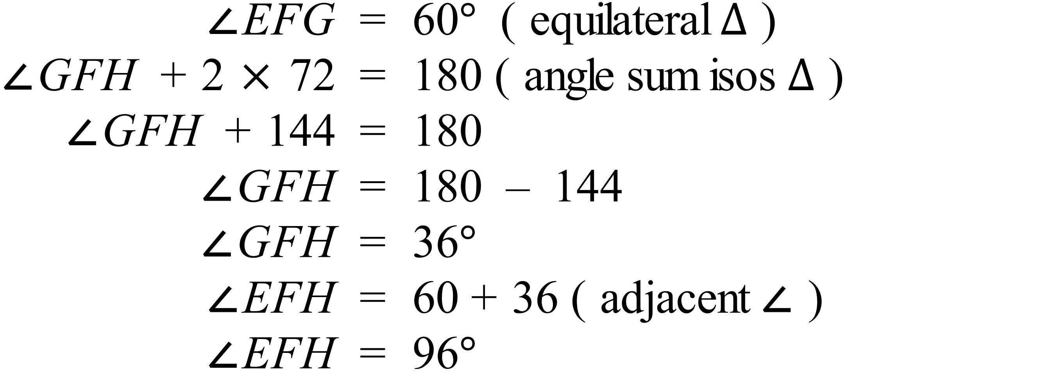 | 3 marks for fully reasoned answer  2 marks for reasoned answer with minor error  1 mark if some minor progress made
 | (b) 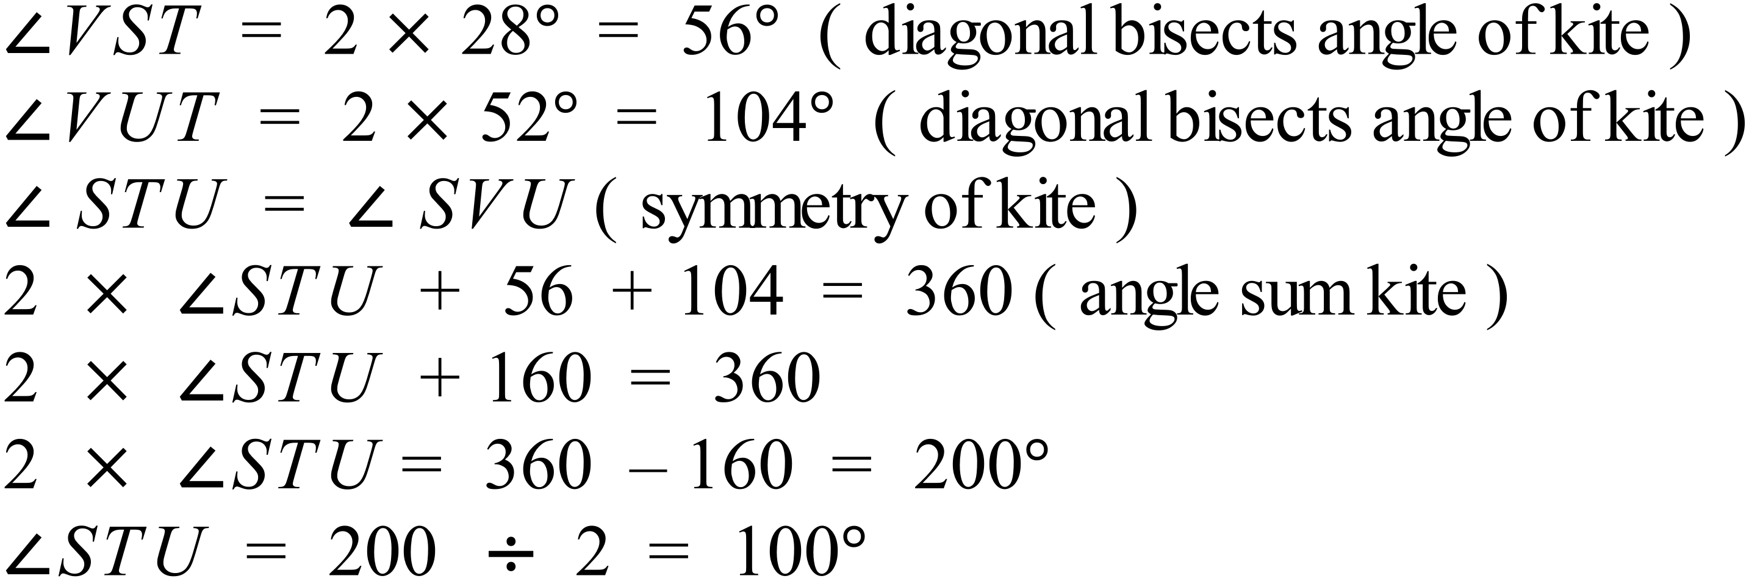 | 3 marks for fully reasoned answer  2 marks for reasoned answer with minor error  1 mark if some minor progress made

